NATIONAL UNIVERSITY OF COMPUTER AND EMERGING SCIENCES
PROGRAM: SOFTWARE ENGINEERING



WEB ENGINEERING LAB
LAB TASK 05

SUBMITTED BY:
Name: Ahmed Ali
Roll No: 22P-9318
Section: BS(SE)-6B

INSTRUCTOR NAME: Sir Zakria
A DEPARTMENT OF COMPUTER SCIENCE

CODE OF QUESTION 1:
<!DOCTYPE html>
<html>
<head>
<title>Lab Task 5 Q1</title>
<style>
body {
font-family: Arial;
margin: 0;
padding: 0;
background-color: white;
overflow-x: hidden;
}
.container {
font-size: 20px;
width: 960px;
margin: 0 auto;
}
header {
background-color: white;
color: purple;
text-align: left;
padding: 15px;
position: relative;
}
.search-box {
position: absolute;
top: 25px;
right: 20px;
background: linear-gradient(to bottom, #d3eb93, #aae435);
padding: 15px;
border-radius: 5px;
}
.search-box input {
padding: 8px;
border-radius: 3px;
}
.search-box button {
background-color: purple;
color: white;
padding: 8px 12px;
border-radius: 4px;
cursor: pointer;
}
.search-box button:hover {
background-color: #5a005a;
}
nav {
background: linear-gradient(to bottom, #edeb62, #dddb32);
padding: 10px;
text-align: center;
margin-bottom: 40px;
}
nav ul {
padding: 0;
}
nav ul li {
display: inline;
margin: 12px 15px;
font-weight: bold;
}
.intro {
background: linear-gradient(to bottom, #d9ec9b, #b5e74a);
padding: 50px;
text-align: left;
margin-bottom: 40px;
font-family: Times New Roman, serif;
font-size: 20px;
}
.content {
width: 100%;
overflow: hidden;
}
.web-development, .course {
width: 460px;
float: left;
padding: 15px;
background: white;
border: 2px solid dimgrey;
border-radius: 10px;
margin-left: 10px;
box-sizing: border-box;
}
h3 {
color: purple;
font-weight: bold;
}
ul {
list-style-type: none;
padding: 0;
}
.web-development ul li::before {
content: "❌ ";
color: red;
}
.course ul li::before {
content: "✔ ";
color: green;
font-size: 20px;
}
ul li {
padding: 5px;
font-size: 16px;
}
footer {
background-color: orange;
color: white;
text-align: center;
padding: 15px;
font-size: 18px;
font-weight: bold;
margin: 40px auto 0;
width: 960px;
}
@media screen and (max-width: 1200px) {
.container, footer {
width: 900px;
}
.web-development, .course {
width: 440px;
}
}
@media screen and (max-width: 992px) {
.container, footer {
width: 700px;
}
.web-development, .course {
width: 100%;
float: none;
margin-left: 0;
}
}
@media screen and (max-width: 500px) {
.container, footer {
width: 100%;
padding: 10px;
}
.search-box {
position: static;
text-align: center;
margin-top: 10px;
}
.intro {
padding: 20px;
font-size: 20px;
}
.web-development, .course {
padding: 10px;
}
nav ul li {
display: block;
margin: 5px 0;
}
}
</style>
</head>
<body>
<div class="container">
<header>
<h1>Coding is Poetry</h1>
<div class="search-box">
<input type="text" placeholder="Search the box">
<button>Search</button>
</div>
</header>
<nav>
<ul>
<li>HOME</li>
<li>WEB DEVELOPMENT</li>
<li>DESKTOP LEARNING</li>
<li>REGISTRATION</li>
<li>CONTACT US</li>
</ul>
</nav>
<section class="intro">
<h1>Want to Learn Coding?</h1>
<p>If you are interested in learning programming and want to fulfill your dreams in the field of programming,
then you are at the best place. The Computer Software Engineering Department at UET Mardan can polish you
and will enhance your programming skills up to the mark. Welcome to the club!</p>
</section>
<section class="content">
<div class="web-development">
<h3>Web Development:</h3>
<ul>
<li>Hyper Text Markup Language</li>
<li>Cascading Style Sheet</li>
<li>JavaScript</li>
<li>Hypertext Preprocessor (PHP)</li>
<li>Bootstrap</li>
<li>WordPress</li>
<li>LARAVEL PHP Framework</li>
<li>Angular Technology</li>
<li>JQuery</li>
<li>AJAX</li>
<li>Mean Stack</li>
<li>MySQL</li>
</ul>
</div>
<div class="course">
<h3>More Options:</h3>
<ul>
<li>C Programming</li>
<li>Object Oriented Programming</li>
<li>Microsoft Visual Basic</li>
<li>C#</li>
<li>JAVA</li>
<li>Python</li>
</ul>
</div>
</section>
</div>
<footer>Ahmed_22p-9318_BS(SE)-6B_Web-Eng.</footer>
</body>
</html>
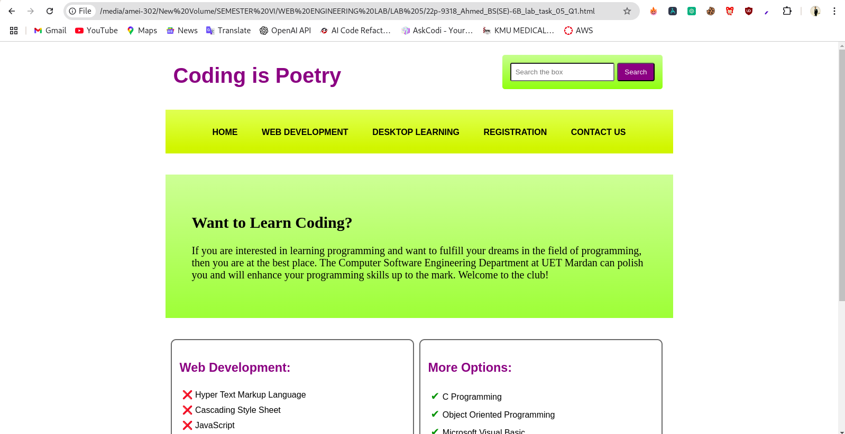
SCREENSHOT, OUTPUT OF QUESTION 1:
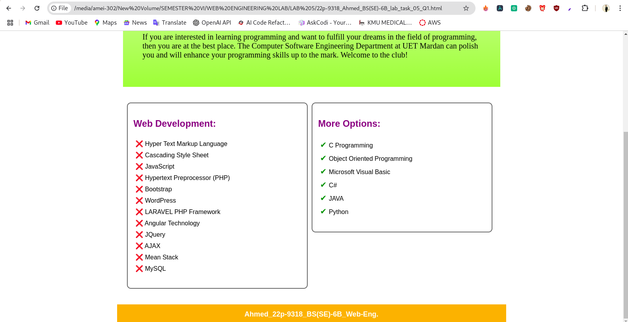

CODE OF QUESTION 2:
<!DOCTYPE html>
<html lang="en">
<head>
<meta charset="UTF-8">
<meta name="viewport" content="width=device-width, initial-scale=1.0">
<title>Websaloon</title>
<style>
* {
margin: 0;
padding: 0;
box-sizing: border-box;
}
body {
font-family: Arial;
overflow-x: hidden;
}
.header {
display: flex;
justify-content: space-between;
align-items: center;
padding: 20px;
background: white;
margin-left: 300px;
}
.nav ul {
list-style: none;
display: flex;
gap: 15px;
margin-right: 250px;
margin-top: 3px;
}
.nav ul li a {
text-decoration: none;
color: #555;
font-size: 13px;
margin-right: 15px;
}

.picbox {
height: 600px;
background: url('websaloon-barn-neon.gif') no-repeat center center/cover;
display: flex;
justify-content: center;
align-items: center;
}
.picbox-content {
background: whitesmoke;
padding: 50px;
max-width: 6000px;
text-align: center;
height: 0 auto;
}
.picbox-content h2 {
font-size: 30px;
font-weight: bold;
}
.picbox-content p {
font-size: 14px;
margin-top: 10px;
margin-bottom: 10px;
}

.picbox1 {
padding: 50px;
text-align: center;
}
.filter-menu ul {
list-style: none;
display: flex;
flex-wrap: wrap;
justify-content: center;
gap: 15px;
padding: 0;
margin-bottom: 30px;
}
.filter-menu ul li {
display: inline;
}
.filter-menu ul li a {
text-decoration: none;
color: black;
font-size: 14px;
padding: 8px 15px;
border-radius: 5px;
}
.filter-menu ul li a.active, .filter-menu ul li a:hover {
background: black;
color: white;
}

.gallery {
display: flex;
flex-wrap: wrap;
justify-content: center;
gap: 20px;
max-width: 1000px;
margin: auto;
}
.gallery img {
width: 30%; /* adjusts three images per row */
max-width: 300px;
height: auto;
object-fit: cover;
display: block;
}

.load-more-container {
text-align: center;
margin-top: 50px;
}

.line {
width: 50px;
height: 2px;
background: black;
margin: auto;
margin-top: 75px;
margin-bottom: 40px;

}

.load-more {
margin-top: 10px;
padding: 10px 20px;
background: black;
color: white;
border: none;
cursor: pointer;
font-size: 14px;
border-radius: 3px;
}

.load-more:hover {
background: #333;
}

footer {
background: #f3f3f3;
padding: 50px 0;
text-align: center;
margin-top: 50px;
}

.footer-container {
max-width: 800px;
margin: auto;
}

.footer-container img {
max-width: 150px
}

.footer-nav {
margin: 10px;
}

.footer-nav a {
color: #555;
margin: 0 10px;
text-decoration: none;
font-size: 14px;
}

.footer-nav a:hover {
color: black;
}

footer p {
font-size: 12px;
color: #777;
margin-top: 10px;
}

@media (max-width: 1200px) {
.header {
padding: 20px;
}
picbox {
height: 500px;
}
}
@media (max-width: 992px) {
.nav ul {
flex-direction: column;
align-items: center;
}
.gallery img {
width: 45%;
}
}
@media (max-width: 500px) {
.header {
flex-direction: column;
align-items: center;
text-align: center;
}
picbox {
height: 400px;
}
.gallery img {
width: 100%;
}
}
</style>
</head>
<body>
<header class="header">
<div class="logo"><img src="websaloon-rood-kleinkopie.png" alt="logo"></div>
<nav class="nav">
<ul>
<li><a href="">HOME</a></li>
<li><a href="">ABOUT US</a></li>
<li><a href="">SERVICE</a></li>
<li><a href="">PORTFOLIO</a></li>
<li><a href="">CONTACT</a></li>
</ul>
</nav>
</header>
<section class="picbox">
<div class="picbox-content">
<h2>WE ARE WEBSALOON</h2>
<p>A small creative no-nonsense advertising agency,<br> focused on internet, e-mail, and social media marketing.<br></p>
<p>We offer: WordPress websites - Webshops - Corporate identity design - Social media marketing & advertising - E-mail marketing.</p>
</div>
</section>
<section class="picbox1">
<div class="filter-menu">
<ul>
<li><a href="" class="active">ALL</a></li>
<li><a href="">DIVERSE</a></li>
<li><a href="">NEW</a></li>
<li><a href="">DESIGN</a></li>
<li><a href="">PRODUCTION</a></li>
<li><a href="">SOCIAL MEDIA</a></li>
<li><a href="">WEB DESIGN</a></li>
</ul>
</div>
<div class="gallery">
<img src="coronel-funbowling-500x500.png" alt="Image 1">
<img src="img2.png" alt="Image 2">
<img src="img3.jpg" alt="Image 3">
<img src="img4.jpg" alt="Image 4">
<img src="img5.jpg" alt="Image 5">
<img src="img6.jpg" alt="Image 6">
</div>

<div class="load-more-container">
<div class="line"></div>
<button class="load-more">LOAD MORE</button>
</div>
</section>

<footer>
<div class="footer-container">
<img src="websaloon-rood-kleinkopie.png" alt="Websaloon Logo">
<nav class="footer-nav">
<a href="">WORK</a>
<a href="">ABOUT</a>
<a href="">CONTACT</a>
</nav>
<p>&copy; 2019 Websaloon</p>
</div>
</footer>
</body>
</html>

SCREENSHOT, OUTPUT OF QUESTION 2:
